TUTORIAL – 13
Selenium Environment Setup
Project Name | Selenium Environment Setup
Module Name | Environment Configuration
Test Case ID | TC-13-01
Tester Name | Vidhi Patel
Application Under Test | Selenium Official Website  (https://www.selenium.dev/)
Tools Used | Python, PyCharm, Selenium WebDriver, Google Chrome
SDLC Model | Agile

Test Scenarios with Screenshots
Scenario ENV01: Create PyCharm project
Scenario ID | ENV01
Scenario | Create PyCharm project
Test Steps | 1. Open PyCharm.  2. Select New Project and name it SoftwareTesting.  3. Create the file tutorial13.py.
Expected Result | Project and Python file are created successfully.
Actual Result | Project and Python file are created successfully.
Status | Pass
Scenario ENV02: Select Python interpreter
Scenario ID | ENV02
Scenario | Select Python interpreter
Test Steps | 1. Open File → Settings → Python Interpreter.  2. Select the Python interpreter available on the computer.  3. Check the installed packages list.
Expected Result | Python interpreter is configured for the project.
Actual Result | Python interpreter is configured for the project.
Status | Pass
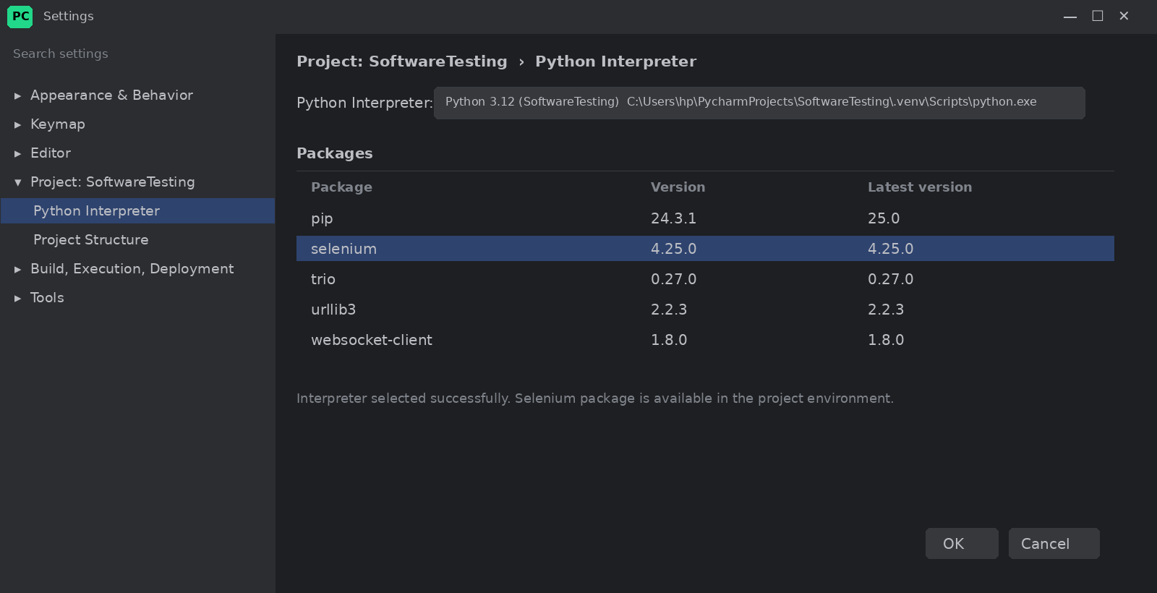
Scenario ENV03: Install and verify Selenium
Scenario ID | ENV03
Scenario | Install and verify Selenium
Test Steps | 1. Open PyCharm → Terminal.  2. Run: pip install selenium.  3. Run: pip show selenium.
Expected Result | Selenium is installed and its details are displayed.
Actual Result | Selenium is installed and its details are displayed.
Status | Pass
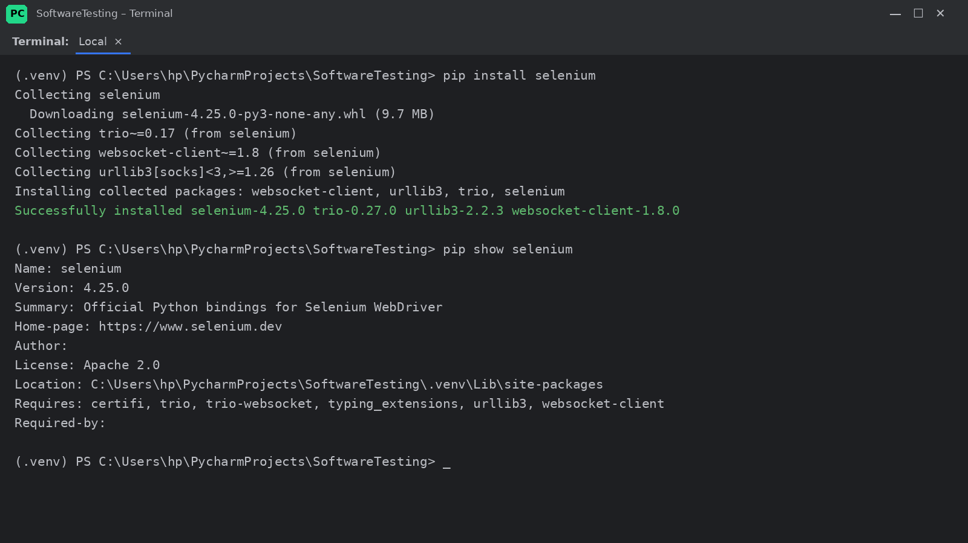
Scenario ENV04: Launch Chrome and open website
Scenario ID | ENV04
Scenario | Launch Chrome and open website
Test Steps | 1. Run tutorial13.py.  2. Chrome is launched by Selenium WebDriver.  3. The Selenium website is loaded.
Expected Result | Chrome launches and the website opens successfully.
Actual Result | Chrome launches and the website opens successfully.
Status | Pass
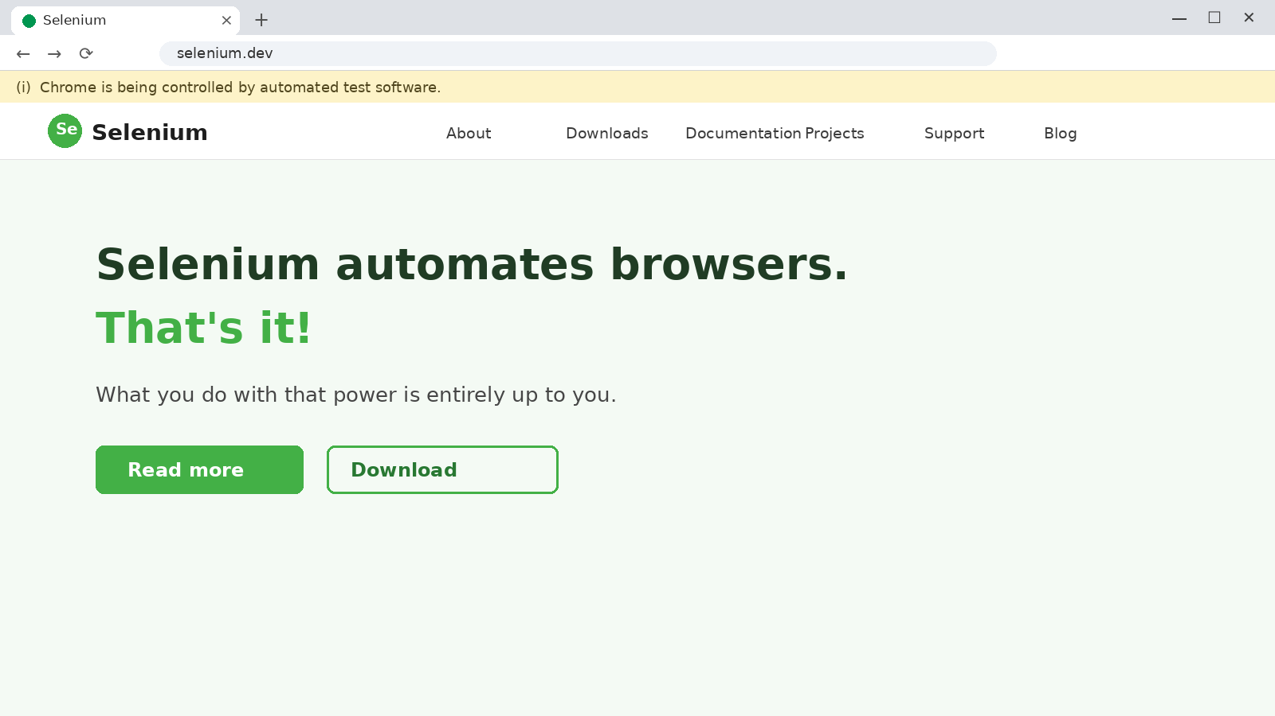

Source Code
from selenium import webdriver

driver = webdriver.Chrome()
driver.maximize_window()
driver.get("https://www.selenium.dev/")

print("Browser launched successfully")
print("Page Title:", driver.title)
print("Current URL:", driver.current_url)

driver.quit()
Source Code Screenshot
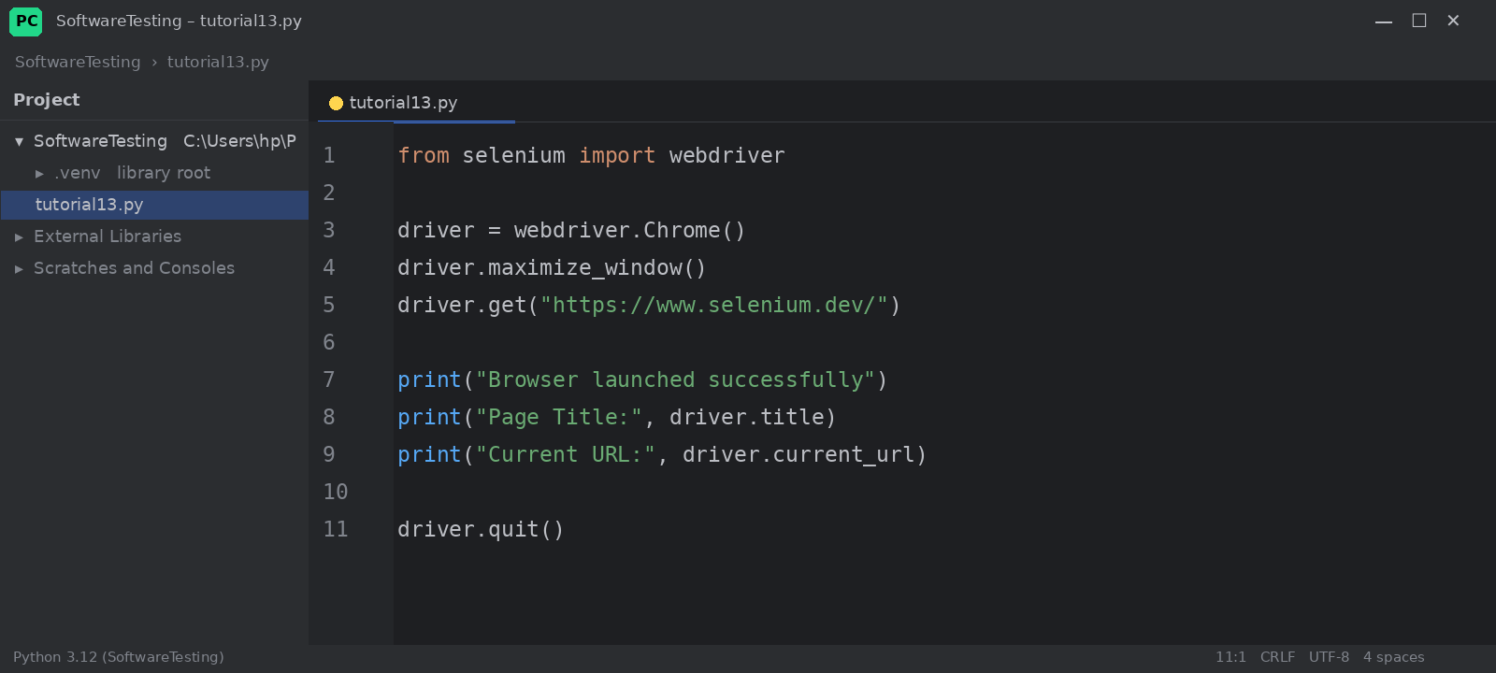

Console Output
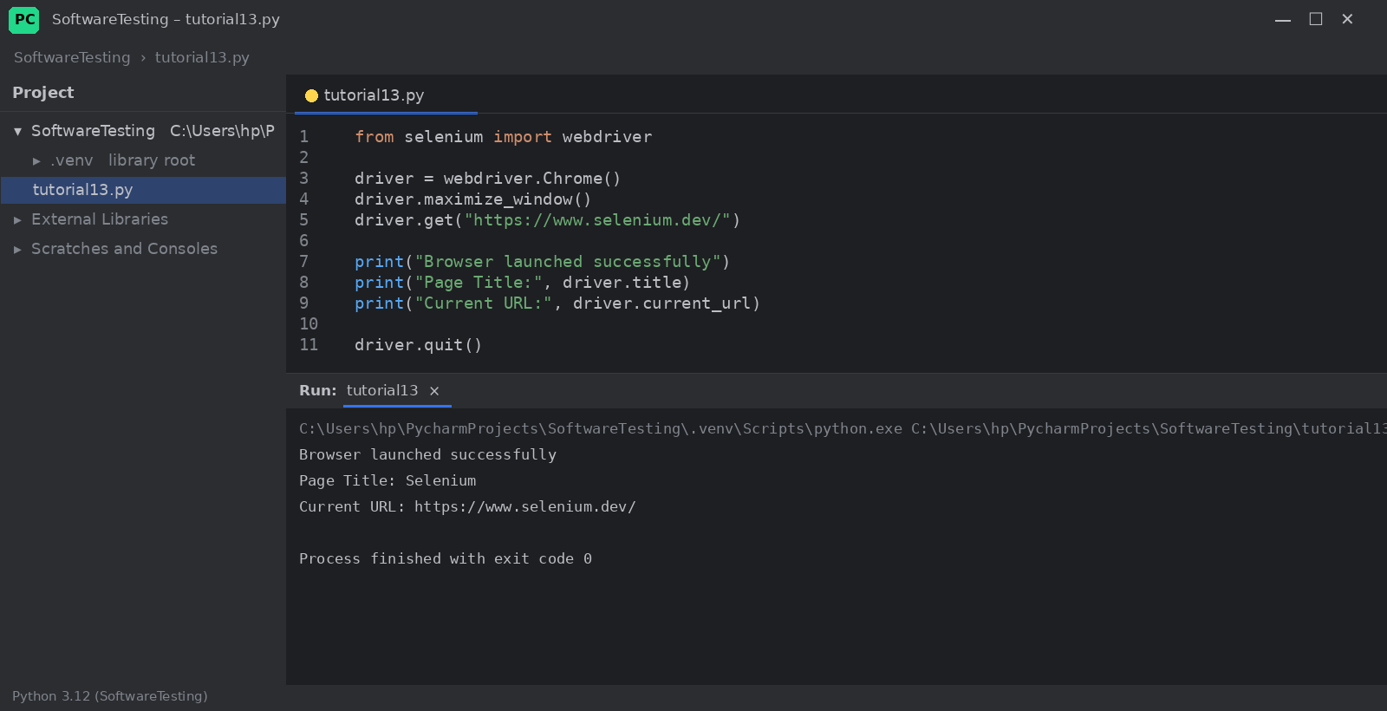
Output:
Browser launched successfully
Page Title: Selenium
Current URL: https://www.selenium.dev/

